1) WWR1
Supervisor
Dr. Wong Wei Ru (weiru@um.edu.my)
Title
D-shaped Photonic Crystal Fiber Incorporating Metal Wire for Plasmonic Sensing
Description / Synopsis
Most of the optical sensors are fabricated in the form of planar waveguide due to its compact form. However, the fabrication process of such waveguide is more complicated and requires higher cost.
This project is attempting to reproduce the sensing process in a cheaper, more sterile fibre based environment. A novel design of optical fibre in microstructured form is a significant step towards realizing the said aim. Surface plasmon is currently the most popular technique used in optical sensing application due to its high sensitivity. Conventional method to coat metal on optical fibre relies on the removal of the cladding of the optical fibre to expose the core. This technique usually does not result in a uniform layer of metal film on the optical fibre due to the difficulty of metal deposition on curved surface (optical fibres are generally circular in shape).
In this project, we propose to design a D-shaped photonic crystal fiber (PCF) incorporated with long, micron-wide metallic wires. The key challenges that this project aims to address would be in achieving uniform, precision-thickness metallic layers that will adhere to a glass surface, introduced via a relatively non-trivial and inexpensive fabrication procedure. Besides, a D-shaped optical fibre structure is introduced to eliminate the additional processing step of removing the cladding of an optical fibre before liquid can be infiltrated into the sensor for sensing applications.
Objectives of the Research
i. To investigate optimized D-shaped PCF geometrical parameters to obtain single-mode light propagation with minimal loss.
ii. To assess the efficiency of plasmonic excitation by incorporating different metallic wire into the D-shaped PCF.
iii. To obtain the bulk and surface sensitivity of the D-shaped PCF based on numerical analysis

2) ASK1
Supervisor
Dr. Anis Salwa Binti Mohd Khairuddin (anissalwa@um.edu.my)
Title
Oil Palm Fresh Fruit Bunches (FFB) Weight Estimation and yield mapping via Video Feed on Mechanical Tractor Grabber (MTG) using Machine Learning (collaboration with Sime Darby sdn bhd)
Description / Synopsis
- Fertilization and other oil palm tree management procedures are very expensive.
- One of the ways to determine the fertilization requirement of oil palm trees is through fresh fruit bunches (FFB) yield of the oil palm tree.
- However, currently the weight of FFB are taken at the palm oil mill weighbridge that they are processed.
- Hence, oil palm estates can only make calculated guess based on the overall data that are obtained from mill’s weighbridge.
- If the yield of oil palm trees can be further mapped and segmented into smaller region, estates can optimize fertilization and other palm tree management procedures.
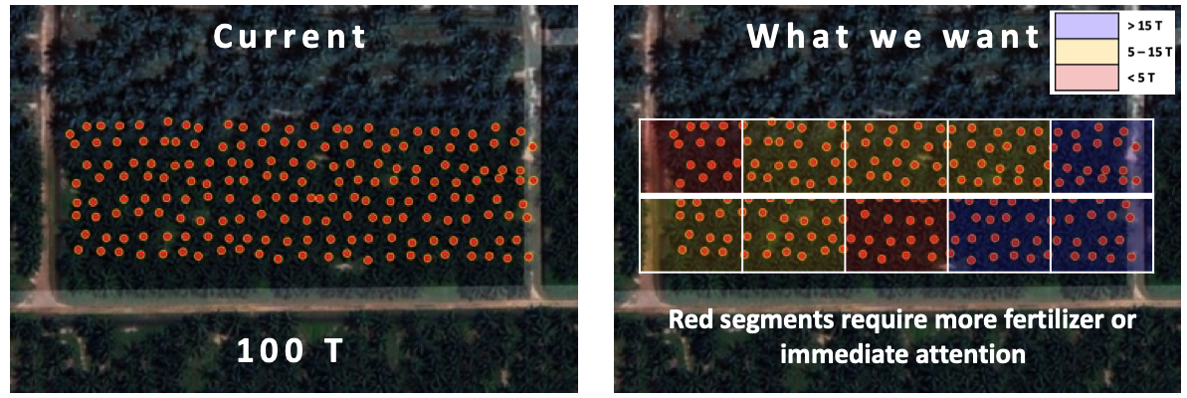
Figure 1. Anticipated deliverable of FFB yield mapping using machine learning.
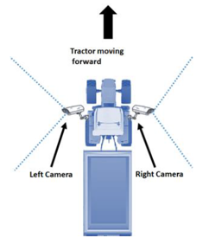
Figure 2. Image of MTG with cameras on both sides during FFB harvesting.
Objectives of the Research
- To develop machine learning for FFB size estimation
- To develop machine learning for FFB weight estimation from the size estimate.
- To develop a mapping framework for the FFB yield from the weight estimate.
- To further segment the FFB yield into smaller area for precision agriculture.

3) ASK2
Supervisor
Dr. Anis Salwa Binti Mohd Khairuddin (anissalwa@um.edu.my)
Title
Oil Palm Fresh Fruit Bunches (FFB) FFB assessment and grade mapping via Video Feed on Mechanical Tractor Grabber (MTG) using Machine Learning (collaboration with Sime Darby sdn bhd)
Description / Synopsis
- Until now, FFB grading are performed at the palm oil mill by competent and experienced FFB graders who manually collect samples and visually evaluate the FFB.
- However, the sample size is only about 30 % of the whole load which means only 50 to 100 bunches are assessed per load of lorry.
- FFB classification or ripeness are graded based on their detached fruitlets as per below:
  - Unripe
  - Under ripe
  - Ripe
  - Over ripe
  - Empty Bunch
- Aside from that, there are also other parameters that are graded:
  - Long stalk
  - Contamination
  - Rodent
  - Dura
- If FFB grading can be done in situ during FFB harvesting by machine learning technique, 100 % of the FFB can be assessed and the data can be used for precision agriculture department for palm tree management procedures prompt response.
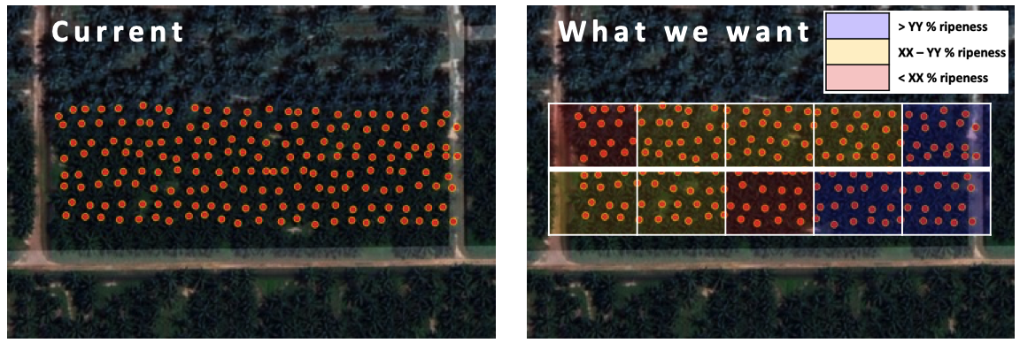 Figure 1. Anticipated deliverable of FFB ripeness mapping using machine learning.

Objectives of the Research
- To develop machine learning for FFB assessment on ripeness.
- To develop machine learning for FFB assessment on other parameters.
- To develop a mapping framework for the FFB grade from the ripeness.
- To further segment the FFB grade into smaller area for precision agriculture.

4) EH1
Supervisor
Dr. Effariza Hanafi (effarizahanafi@um.edu.my)
Title
IoT based Monitoring System for Precision Agriculture
Description / Synopsis
Internet of Things (IoT) is a new technology paradigm envisioned as a global network of machines and devices capable of interaction with each other. The IoT is recognised as one of the most important areas of future technology and is gaining vast attention from a wide range of industries and web technology (industrial revolution 4.0 and web 3.0), including smart farming and agriculture. Precision agriculture is set to provide higher productivity and a better use of resources as compared to the traditional methods where it allows the right amount of resources to be used for an exact duration of time. This project focuses on the application of IoT for precision agriculture, primarily on monitoring system. A mobile application which includes a graphical user interface (GUI) will be developed to allow the users to view the status of the required parameter from the agriculture field. In addition, the system also includes yield prediction monitoring, where machine learning algorithm for yield prediction will be integrated with the application. The easy access of information allows the users to take the necessary action and thus improve crop production.

5) JV1
Supervisor
AP. Ir. Dr. Jeevan Kanesan (jievan@um.edu.my)
Title
Self-Organizing Map using Optimal Control
Description / Synopsis
Background
Self Organizing Map (SOM) is used widely as Artificial Intelligence tool for clustering, classification, detection and autonomous control of many engineering problems. The SOM learns relationships between input/output dataset via weight update using back propagation and feedforward error loss minimization. However, in back propagation SOM (bp-SOM), the slow learning process speed becomes obstacle for bp-SOM to be employed in real time and dynamic system applications. To increase the learning speed, SOM is modeled as Optimal Control problem hence giving more flexibility to engineers to manipulate many attributes of optimal control that can be further improved, thus enhancing SOM to obtain more accurate results in shorter period.

Problem Statement
The selection of initial weights in bp-SOM are carried out randomly. By using Optimal Control, the initial weights are determined numerically, and this conveniently minimizes the error loss of SOM unlike randomized initial weights of bp-SOM that likely would not guarantee error loss minimization of DNN.
Objectives of the Research
1. Minimize the error loss of bp-SOM using optimal control.
2. Determining the initial weights of bp-SOM via numerical methods.
Expected Outcomes
1. Convert bp-SOM as optimal control problem >50%
2. Improving the learning speed of Algorithm in 1. >65%
3. Reduce the error loss of Algorithm in 1. >80%
Equipment Needed
Laptop, Desktop, Matlab (Software)

6) JV2
Supervisor
AP. Ir. Dr. Jeevan Kanesan (jievan@um.edu.my)
Title
Minimization of Covid-19 epidemic and movement control order as optimal control strategy.
Description / Synopsis
Background
On 18 March, Malaysia began the implementation the movement control order. On 25 March, the prime minister through a live national broadcast announced a first extension of the MCO to last until 14 April. There were, however, considerations of a further lockdown until late April or May as the number of cases in Malaysia is expected to peak in mid-April, according to the World Health Organization (WHO). On 10 April, the prime minister announced a second extension of the MCO by another fortnight until 28 April, noting that his decision was to give space to the healthcare personnels battling the COVID-19 outbreak, apart from preventing the virus from spreading again and to avoid another increase of cases if the MCO is lifted too early. On the night of 23 April, PM announced a third extension of the MCO by two weeks till 12 May, with the possibility of further extensions.
These MCO extensions have severe impact on businesses costing Government RM 1.8 billion daily, hence optimal control is used to reduce MCO while also minimizing the epidemic of COVID-19.

Problem Statement
Covid-19 epidemic growth is minimized by Enhanced MCO and Conditional MCO. The financial cost of EMCO and CMCO is high. How to schedule EMCO and CMCO in order for it to be cost effective?
Objectives of the Research
1)Minimize COVID-19 epidemic.
2)Minimization the CMCO and EMCO cost
Expected Outcomes
1. Minimized COVID-19 epidemic>50%
2. Reduced side effects of CMO.>65%
3. Effective schedule.>80%
Equipment Needed
Laptop, Desktop, Matlab (Software)

7) JV3
Supervisor
AP. Ir. Dr. Jeevan Kanesan (jievan@um.edu.my)
Title
Targeted therapy for cancer patients using optimal control and swarm intelligence
Description / Synopsis
Background

Targeted drug delivery systems have been developed to optimize regenerative techniques. The system is based on a method that delivers a certain amount of a therapeutic agent for a prolonged period of time to a targeted tumor area within the body. This helps maintain the required plasma and tissue drug levels in the body, thereby preventing any damage to the healthy tissue via the drug. The drug delivery system is highly integrated and needs various disciplines, such as chemists, biologists, and engineers to optimize this system. Optimal control and swarm intelligent are used to maximize the drug to targeted area.

Problem Statement

Cancer/Tumor growth is minimized by targeted therapy which penetrates only on cancer location. However targeted therapy must be effective in killing cancer as any failure will cause cancer aggravation. Effective targeted therapy is obtained by optimization of the targeted therapy for the patient. How to schedule targeted therapy to minimize cancer cells?

Objectives of the Research
1)Minimize tumor via optimal targeted therapy
2)Minimize damage to healthy cells.
Expected Outcomes
1.Minimum loss of healthy cell.
2. Patient immunity under control.
3.Personalized Optimal chemotherapy schedule
Equipment Needed
Laptop, Desktop, Matlab (Software)

